**15 Mar 2019** **The Weekly Bulletin of Rotary Club of Kathmandu Mid-Town** **bc-24.3/019**

|  |
| --- |
| C:\Users\Public\Documents\RIP T1819_EN.png |

District: 3292 Web:www.rotarymidtown.org.np Club Id: 26776

**MARCH IS WATER AND SANITATION** **MONTH**

Rotary clubs plan and implement programs to provide clean water and sanitation in the communities such as

- improving sanitation facilities by providing improved toilets,

- promoting good hygiene habits through education,

- implementing rainwater harvesting systems to collect and store rainwater for drinking or recharging

underground aquifers,

- providing home water-treatment capability through the use of filters, solar disinfection, or flocculants, to

make drinking water safe,

- promoting low-cost solutions – chlorine tablets or plastic bottles that can be exposed to sunlight in order to

improve water quality..

**Weekly Club Meeting # 1479 held on Friday 1 Mar 2019**

Guest speaker Ms Bina Pradhan talked about Nuwakot Livelihood Coffee Project and how the project helping local women farmers in capacity building and rural earnings.

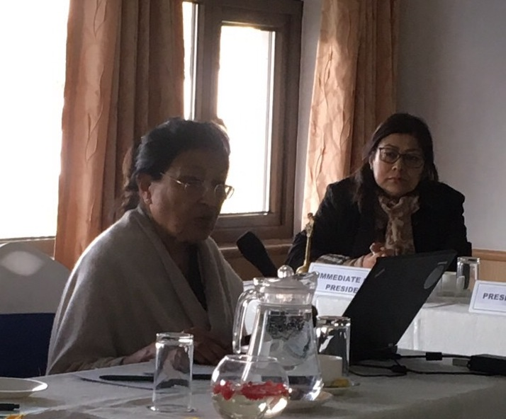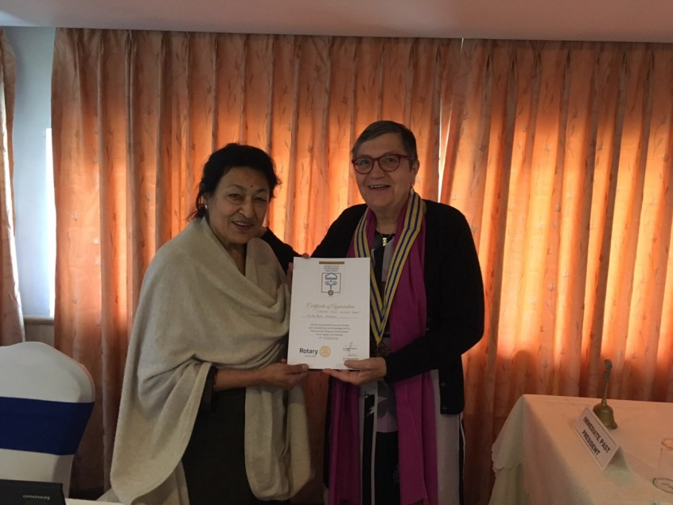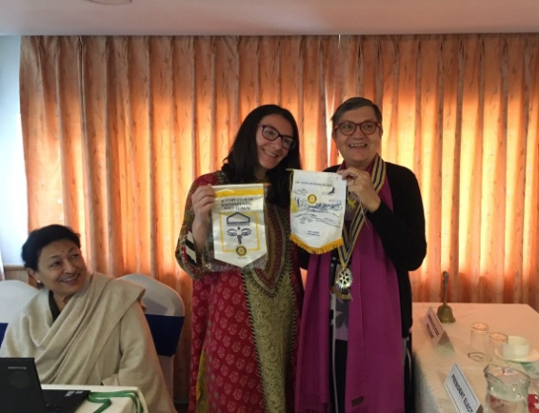

Guest speaker on the session President Jo handing over a certificate of appreciation Exchanging Club banners

**Weekly Club Meeting # 1480 held on Friday 8 March**

Guest speaker, Mrs Binita Adhikari, Director/ counseling psychologist at Antardristi Nepal an organization, whose mission is to empower people to prevent sexual abuse and to support the survivors through healing process, gave a presention on "Women empowerment and child sexual abuse."

She presented a very disheartening, and painful status of Child Sexual abuses in the country.

**Club Meeting # 1481 Friday 15 March**

Joint meeting with Rotaract Club of Kathmandu Mid-Town

Rotaract President Sushma Shrestha will give a presentation on Rotaract activities, plans and achievements during the year. They are usually inspiring to the parent club!

**Club Meeting # 1483 in Simpani**

Club meeting # 1483 is going to be held in Simpani, the Water Project site, on Saturday 30 March 2019. No meeting on Friday 29th March. Club members are encouraged to attend this project-site meeting. More details to follow.

**Rotary Peace Seminar:**

Happiness Is Not The Absence Of Problem

But Ability To Deal With Them

***Lord Buddha***

Rotary Peace Seminar is scheduled to be held on 15-16 March 2019, at Balthali, Kavrepalanchowk.

Seminar Theme : ***Inspire people around you to promote PEACE***

Registration within Wednesday, 13 March. Information by email on Thurday, 14 March !

**Late Bhawana Thapaliya Breast Cancer Awareness Campaign:**

Rotaract Club of Kathmandu Mid-Town and Rotaract Club of Kathmandu Medical College jointly organized "Late Bhawana Thapaliya Breast Cancer Awareness Campaign" recently at Tri-Ratna Cooperative School under the guidance and support of PP Dr Chandra L Tuladhar, Chair – Youth Service.

Altogether 48 participants, comprising school teachers, students and local women, took part in the program.

~~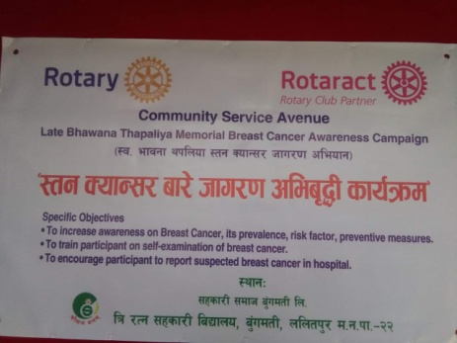 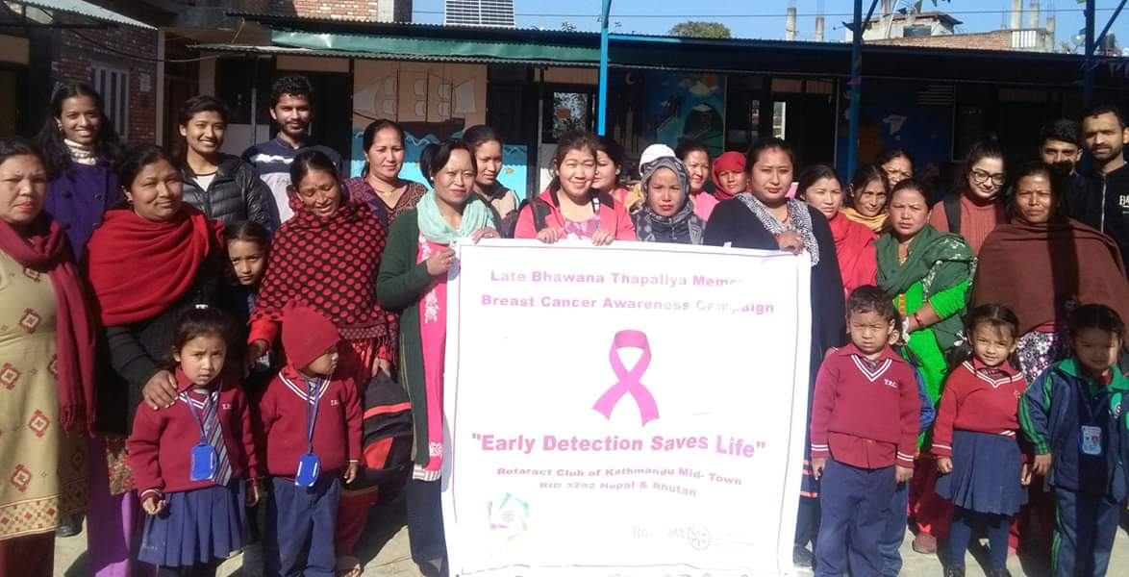 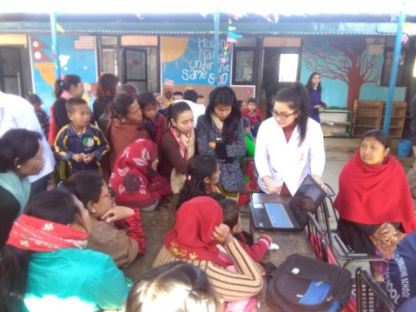~~

**Do you Know** **?**

Antarctica is hurling its guts into the ocean. And it's happening six times faster now than it was even four decades ago. The southern, frozen continent lost an average of 252 gigatons of ice a year to the sea between 2009 and 2017. Between 1979 and 1990, it lost an average of just 40 gigatons per year. As the sea ice at the North Pole [melts away](https://www.livescience.com/61182-2017-arctic-report-card-melting.html), it doesn't directly raise sea levels. North polar ice is already floating on the ocean, so turning it from solid to liquid doesn't add to the total volume of water in the seas. Ice loss in Antarctica is a big deal. Antarctica is a landmass buried beneath ice. And it holds the largest reserve of frozen, landlocked water anywhere on the planet. Any ice loss on Antarctica directly contributes to the total volume of water in the oceans, and raises sea levels. And 252 gigatons a year is a meaningful number when it comes to sea levels. A gigaton is a billion metric tons, and each metric ton is 2,204 pounds — a bit less than the weight of a small car. Each gigaton of ice that flows into the ocean is roughly equivalent in mass to about 720 million vehicles flung overboard. You could fling [every car on Earth](https://www.huffingtonpost.ca/2011/08/23/car-population_n_934291.html) into the ocean and the mass probably wouldn't top 2 gigatons.

*Read more on https://www.livescience.com/64505-antarctica-ice-loss.html*

**A THOUGHT FOR THE DAY**

[The art of being happy lies in the power of extracting happiness from common things.](http://www.brainyquote.com/quotes/quotes/g/georgewash106292.html)

[*Henry Ward Beecher*](https://www.brainyquote.com/authors/henry_ward_beecher)

On Lighter Side:

A sweet young blonde is taking her first airplane ride. As the plane gains altitude, she complains to the flight attendant that her ears are popping.

The flight attendant gives her some chewing gum and assures her that many people experience the same discomfort.

When they land, the sweet young blonde thanks the flight attendant.

"The chewing gum worked fine," she says, "but tell me, how do I get it out of my ears?

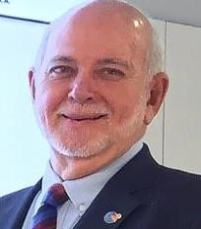

Ask your members what they love, what they are passionate about and how they can bring

value to your club. For ultimately, Rotary is all about ‘people in action’ who do

transformational projects. Every Rotarian must feel there is an inherent value in belonging

to this global voluntary organization.

**RI President Barry Rassin**

Please send information on club activities, progress reviews on service projects, relevant photos etc to:

BC Editor: RR Shrestha email: rryesrr@gmail.com

## 15 Mar 2019 The Weekly Bulletin of Rotary Club of Kathmandu Mid-Town bc-24.3/019

Rotary News May 2018, Awaken the soul of Rotarians: Barry Rassin